# Name: ANSHU PATEL

Roll No: **2108410100014**

**Computer Network (KCS 653)**

Rajkiya Engineering College, Sonbhadra

|  |  |  |  |
| --- | --- | --- | --- |
| **Sno** | **List of Practicals** | **Date** | **Sign** |
| 01 | Cisco Packet Tracer (Topology 1 and Topology 2 ) |  |  |
| 02 | Cisco Packet Tracer ( TREE  Topology) |  |  |
| 03 | WireShark |  |  |
| 04 | Cisco Packet Tracer ( ICMP  request) |  |  |
| 05 | Wire Cutting Exercise |  |  |
| 06 | Capturing and Analyzing ethernet  frames |  |  |
| 07 | Basic Subnetting and Routing Exercise (Fixed and Variable  length) |  |  |

## Computer Networks Lab -PRACTICAL # 1

###### Cisco Packet Tracer:

Use the Cisco Packet Tracer Simulation Tool to design the following network topologies in Realtime mode. Use the Simulation mode to test the ICMP Ping service (using a Simple PDU) on both the networks:

*Topology1*:

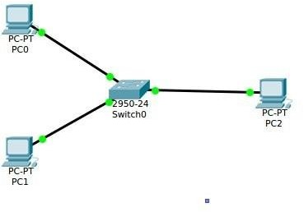

In the above topology, replace the **switch** with a **hub** and compare the behaviour.

*Topology 2*:

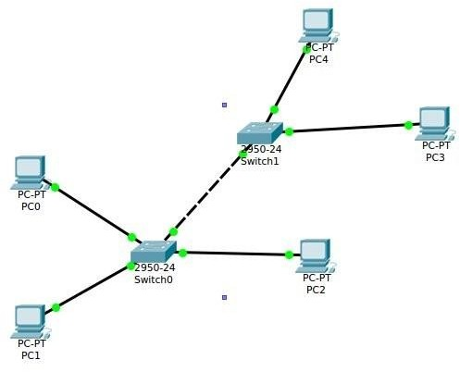

# SOLUTION

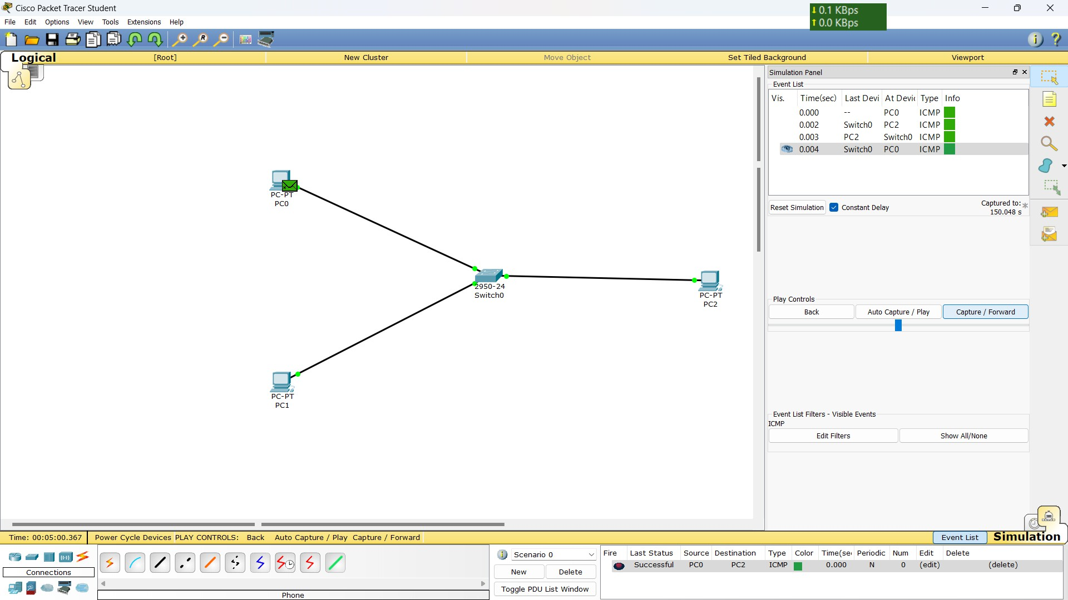

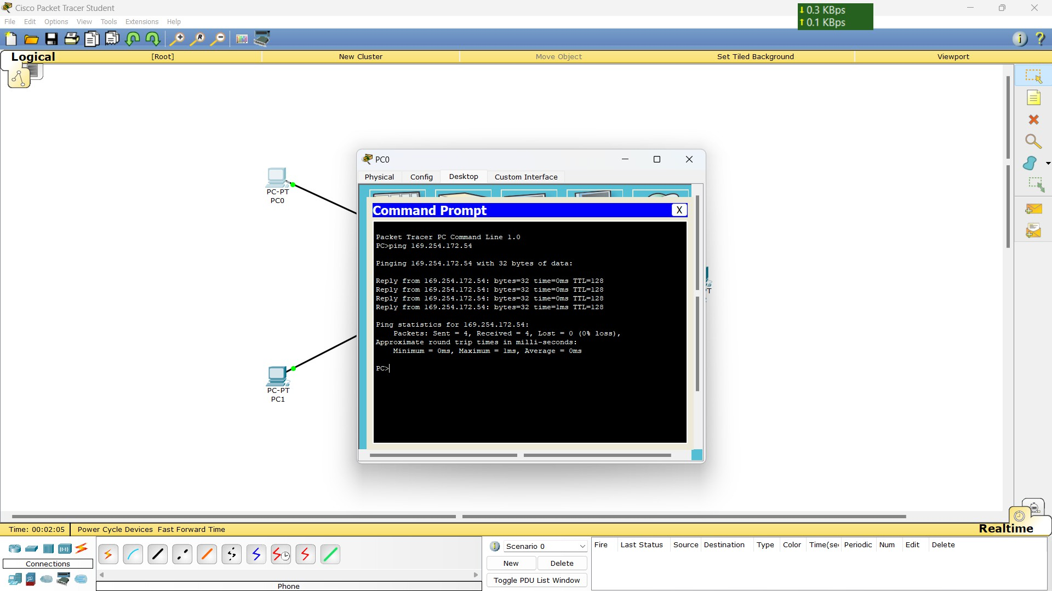

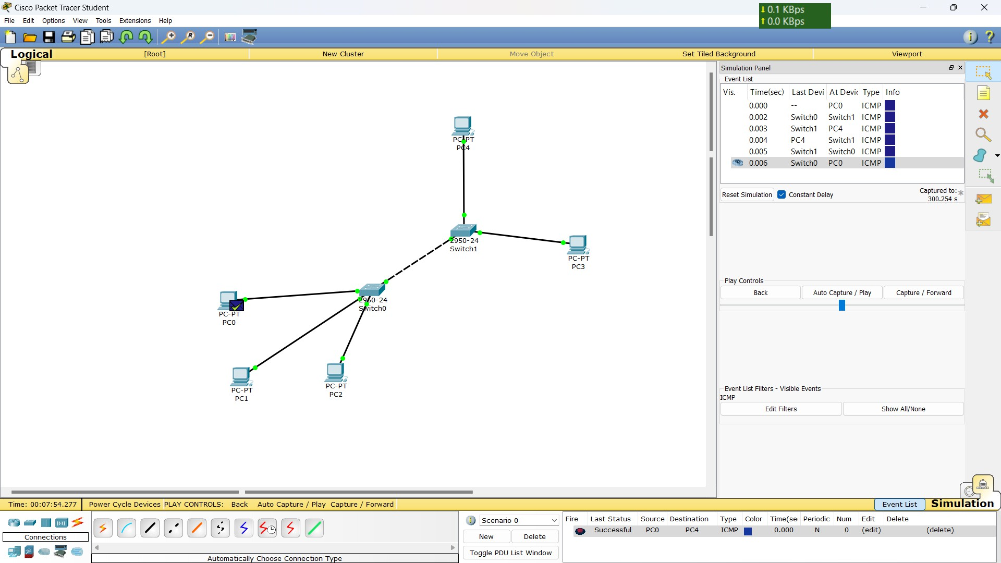

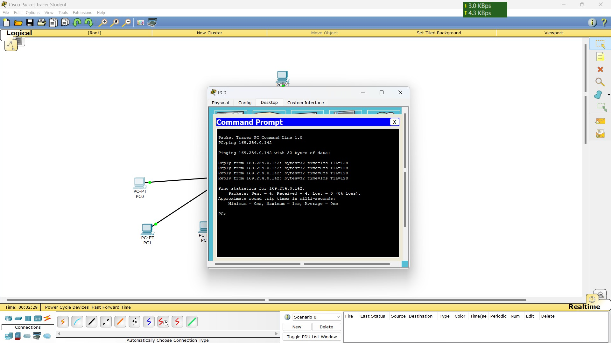

## Computer Networks Lab - PRACTICAL # 2

Assignment :

1. Construct a tree topology that uses a primary hub/switch to connect three secondary hubs/switches. The primary hub/switch has two hosts connected directly to it, whereas each of the three secondary hubs/switches have five directly connected hosts. Simulate the above constructed tree network using ICMP request/response packets to perform the following:
   1. Check connectivity between any two hosts directly connected to the same secondary hub/switch (Do it for all the three secondary hubs/switches).
   2. Check connectivity between two hosts directly connected to the primary hub/switch.
   3. Check connectivity between a host connected to the primary hub/switch and a host connected to any of the three secondary hubs/switches.
   4. Check connectivity between a host connected directly to a secondary hub/switch and another host connected directly to some other secondary hub/switch.
2. Construct a LAN of five hosts arranged in a ring topology and check connectivity between the hosts by sending ICMP request/response packets.
3. Use Command Line prompt to PING hosts in a network and check their ARP Tables. (Refer the student packet tracer manual)

Solution :

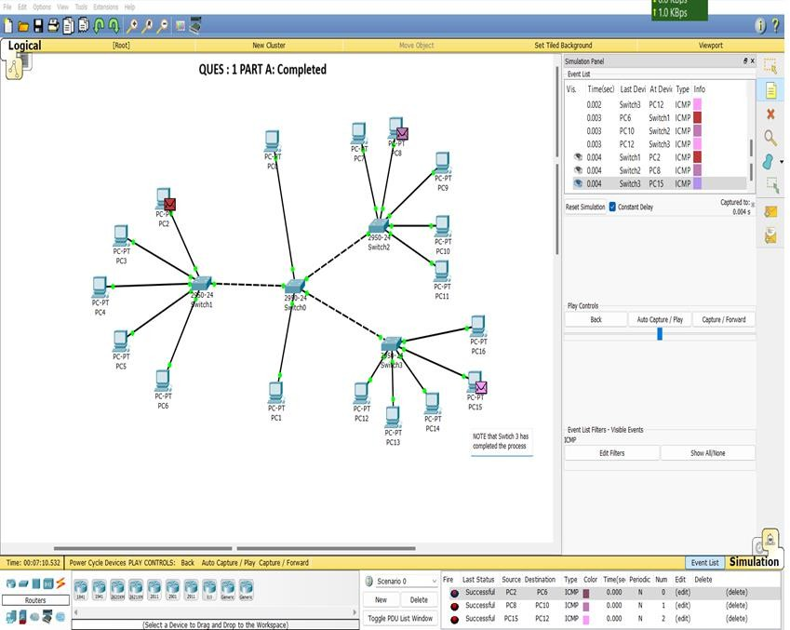

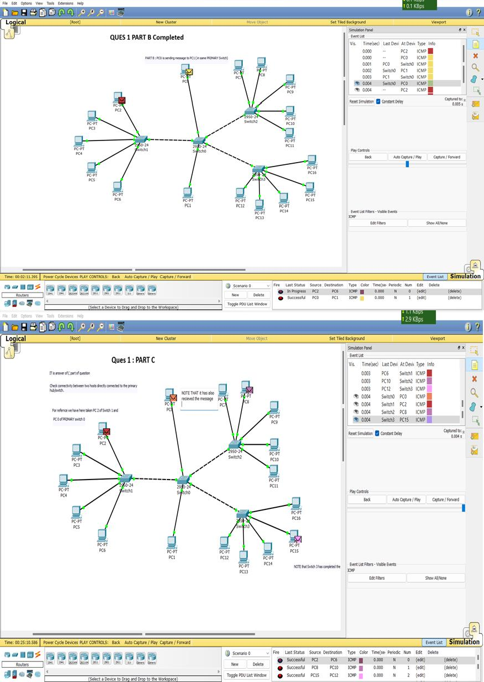

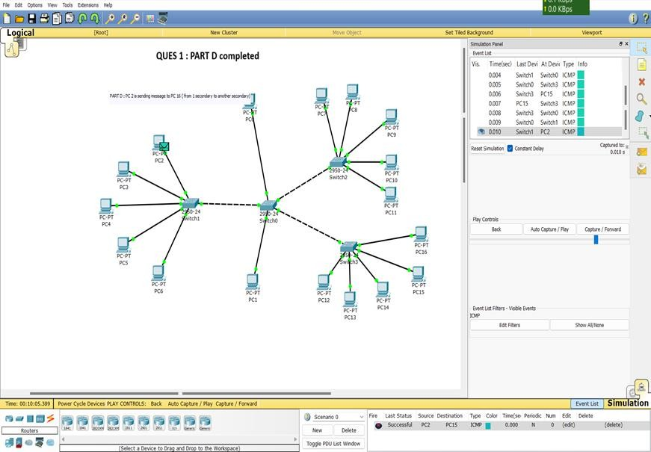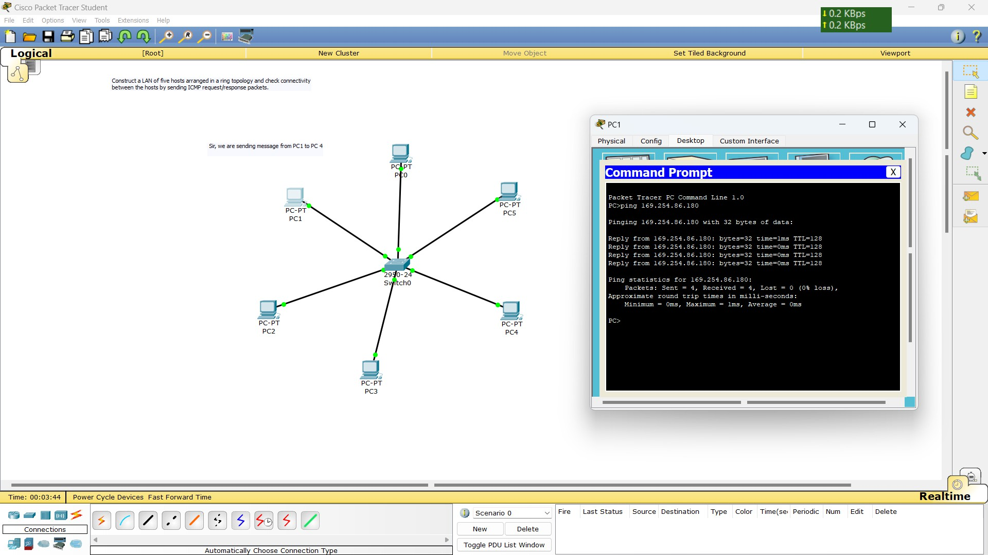

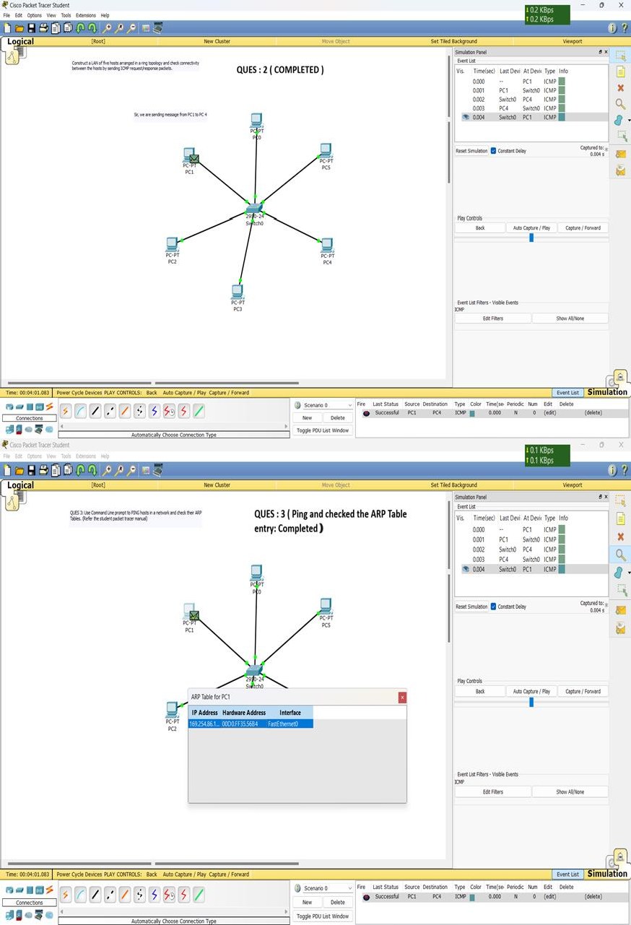

**Computer Networks Lab - PRACTICAL # 3**

1. List 3 different protocols that appear in the protocol column in the unfiltered packet-listing window in step 7 above. Ans: TCP, ARP, HTTP, SSL
2. How long did it take from when the HTTP GET message was sent until the HTTP OK reply was received? (By default, the value of the Time column in the packet-listing window is the amount of time, in seconds, since Wireshark tracing began. To display the Time field in time-of-day format, select the Wireshark View pull down menu, then select Time Display Format, then select Time-of-day.)

Ans: Time taken in sending and receiving the HTTP messages:

HTTP GET message was sent at: 21:35:52.295390 HTTP OK reply was received at: : 21:35:52.602691 Time taken = 21:35:52.602691 - 21:35:52.295390

= 0.307301 seconds

1. What is the Internet address of the gaia.cs.umass.edu (also known as www- net.cs.umass.edu)? What is the Internet address of your computer?

Ans: Internet address of the gaia.cs.umass.edu: 128.119.245.12

Internet address of MY computer: 172.16.224.2

1. Print the two HTTP messages (GET and OK) referred to in question 2 above. To do so, select Print from the wireshark File command menu, and select the “Selected Packet Only” and “Print as displayed” radial buttons, and then click OK.

Ans.

GET messages:

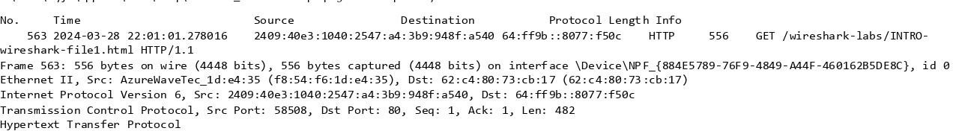

OK Messages:

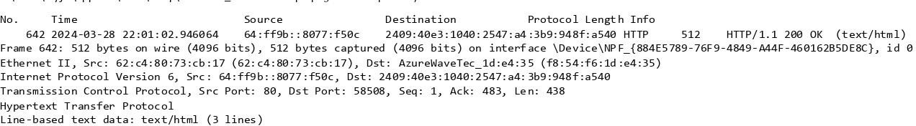

## Computer Networks Lab - Assignment # 4

Cisco Packet Tracer:

Use Cisco Packet Tracer to construct two separate star networks comprising of four hosts each (Use hubs to create both the star networks). Now use a layer-2 switch to provide connectivity between both the star networks. Simulate the above network using ICMP request/response packets to perform the following:

1. Assign Static IP addresses (manual configuration) to the host devices. Apply ARP and ICMP filters before starting the simulation.
2. Check connectivity using ICMP/PING between any two hosts in the same star network (Do it for both star networks).
3. Check connectivity using ICMP/PING between a host of one star network and a host of the other star network.
4. Will there be any change in the nature of communication, if the layer-2 switch is replaced by a simple hub?
5. Check/Print ARP tables of all communicating hosts before and after sending of the ARP packets.
6. Check/Print MAC tables of all the switches before and after sending the ICMP request packet.
7. Print Ethernet Header and PDU of ARP request/response messages.
8. Print PDU of ICMP request/response messages.

SOLUTION:

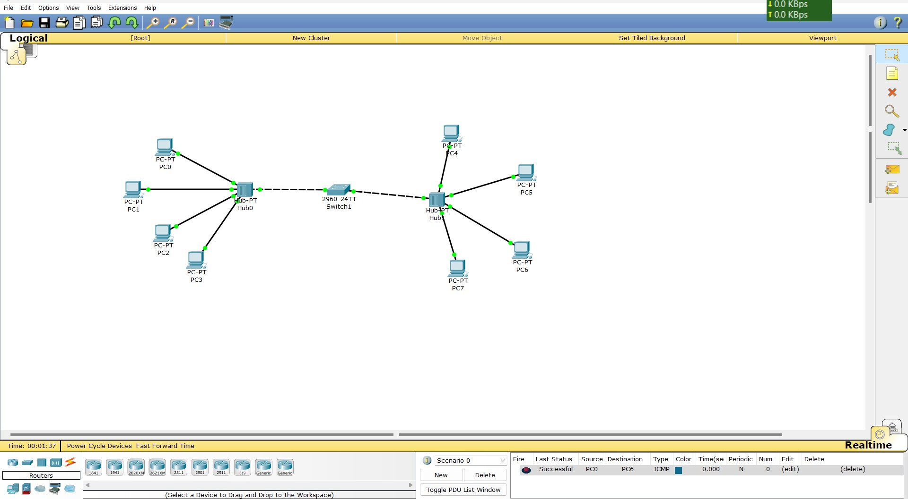a)

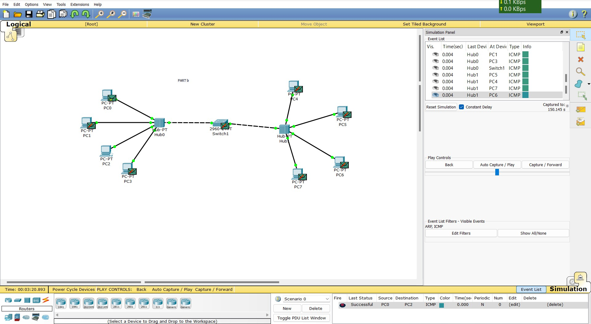b)

c)

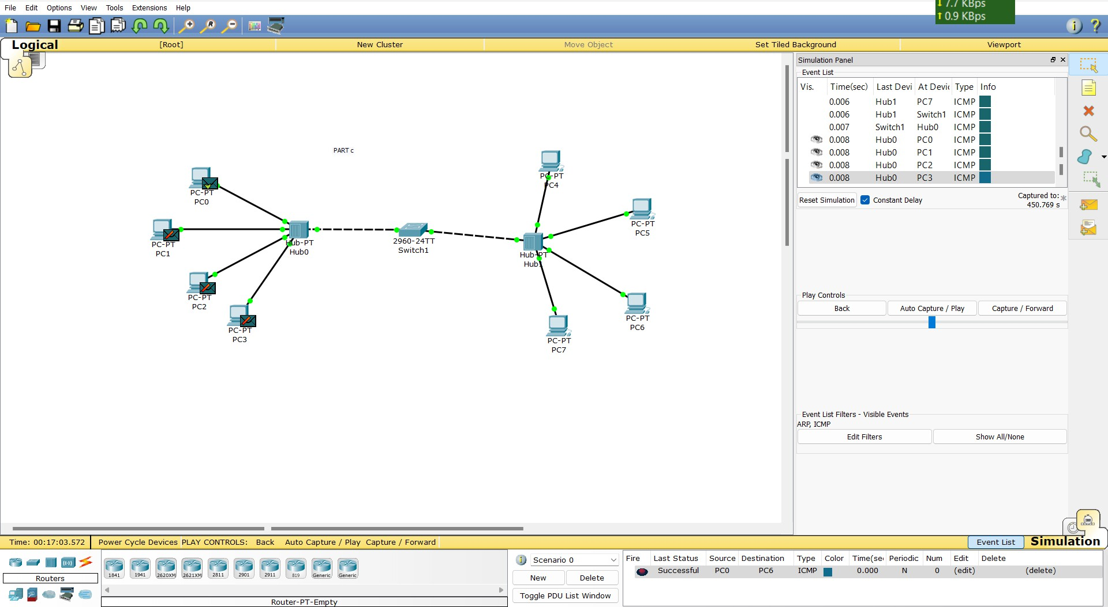

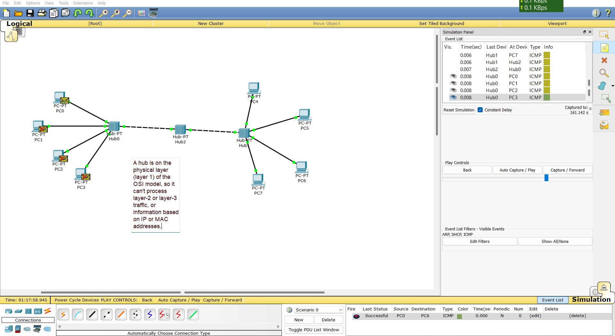d)

### ( BEFORE SENDING)

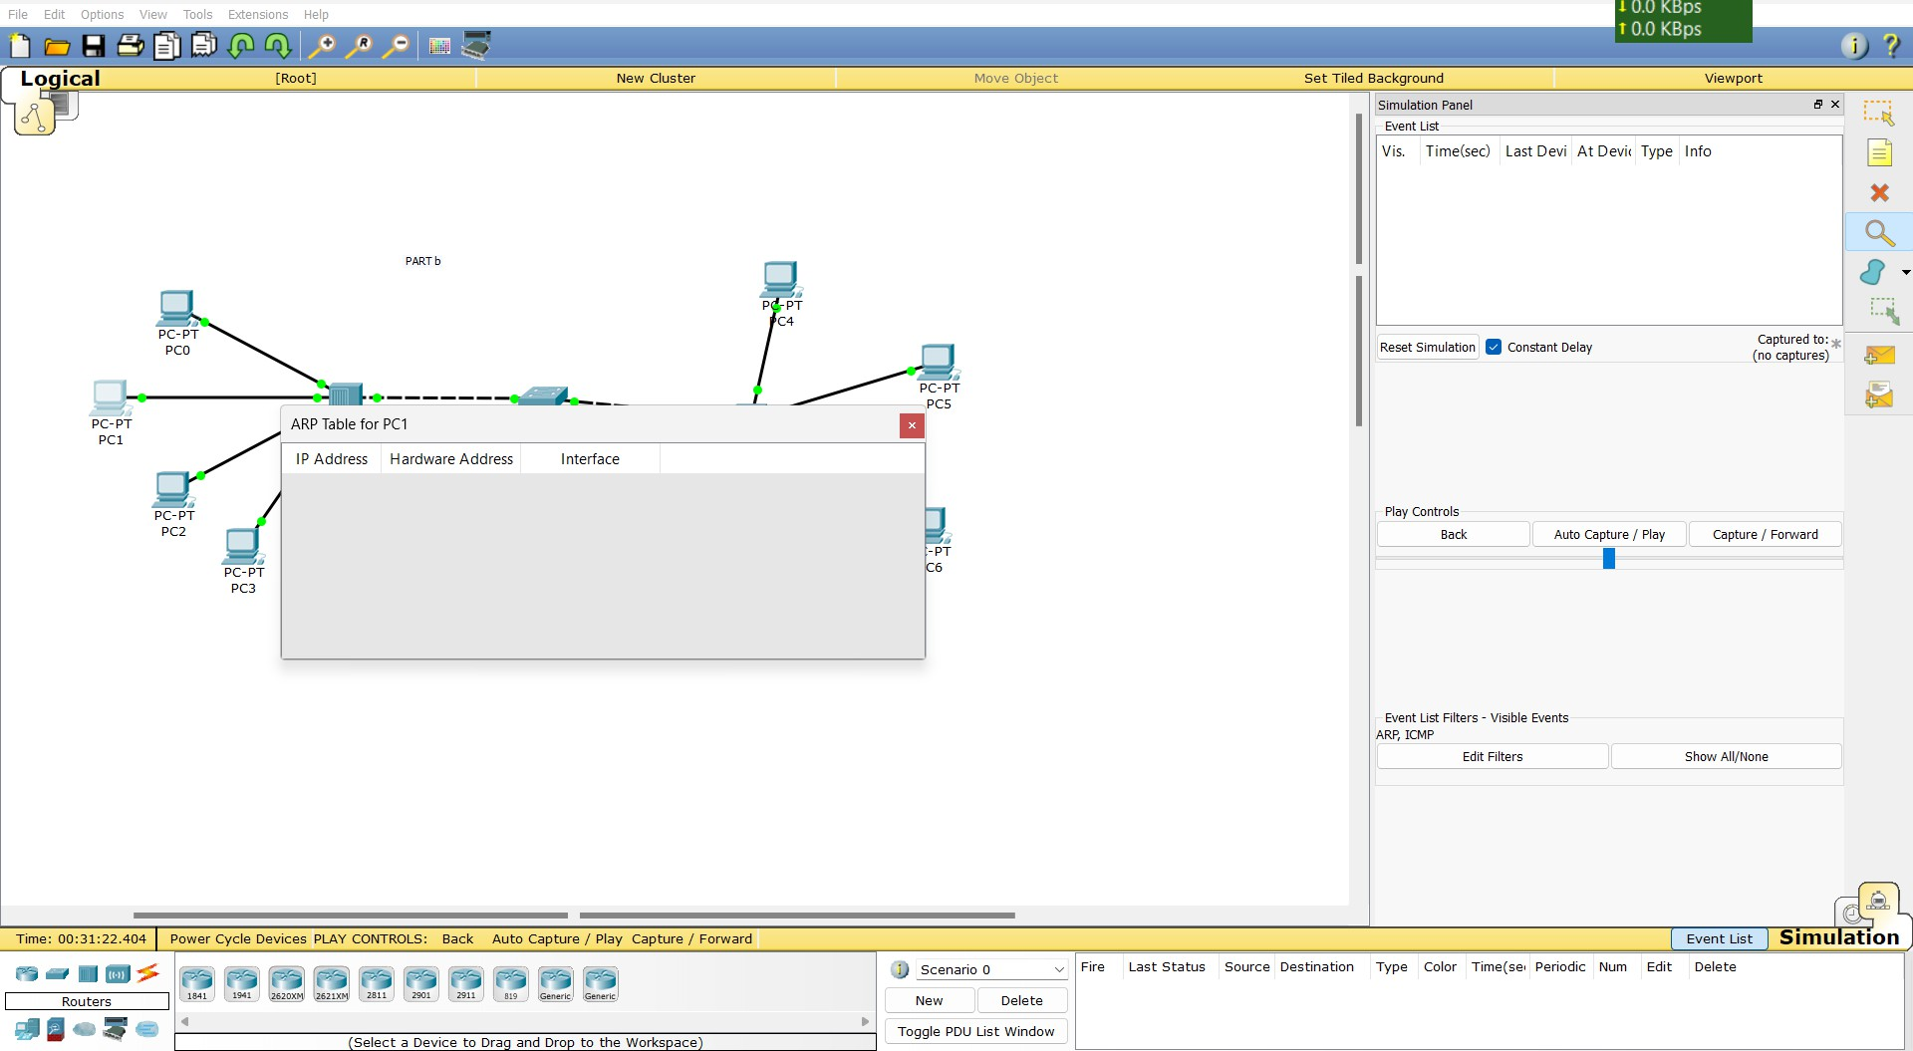

* + 1. 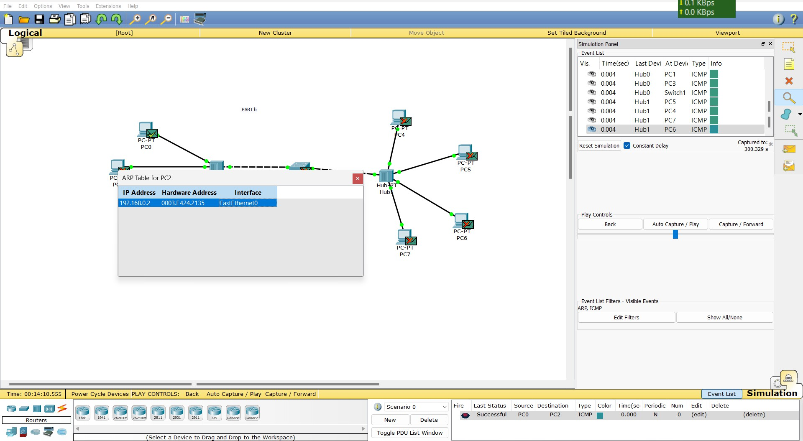(AFTER SENDING)
    2. (After SENDING)

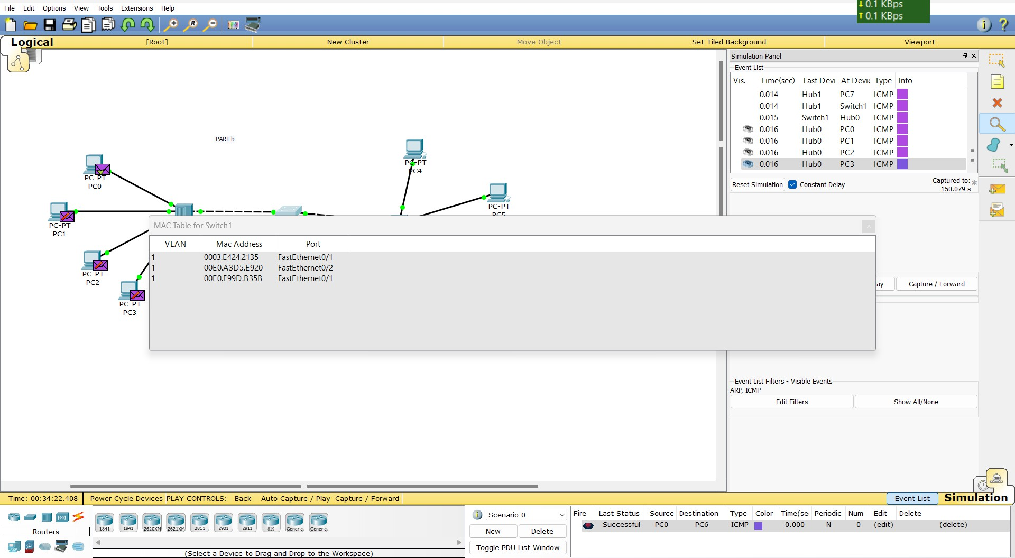

### (BEFORE SENDING)

* 1. 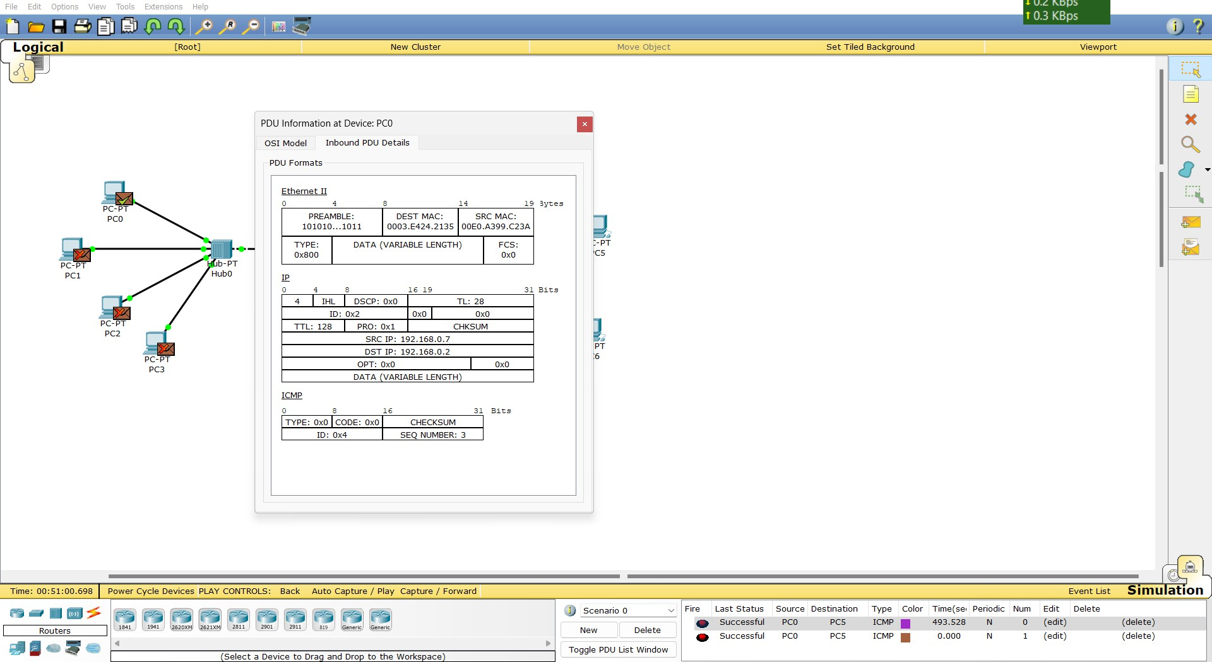( Ethernet header Information)

1. 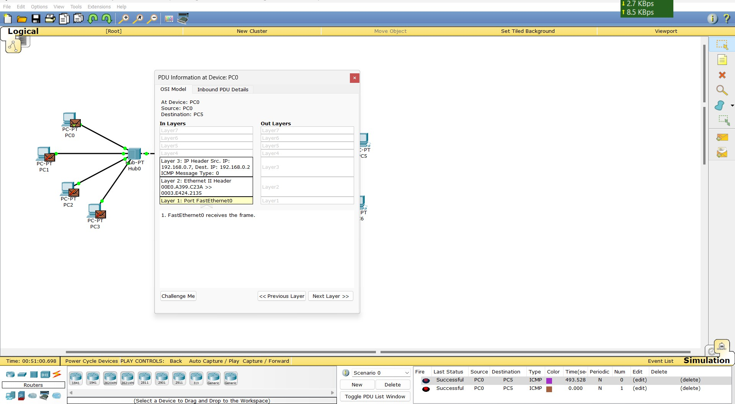(PDU Information)
2. 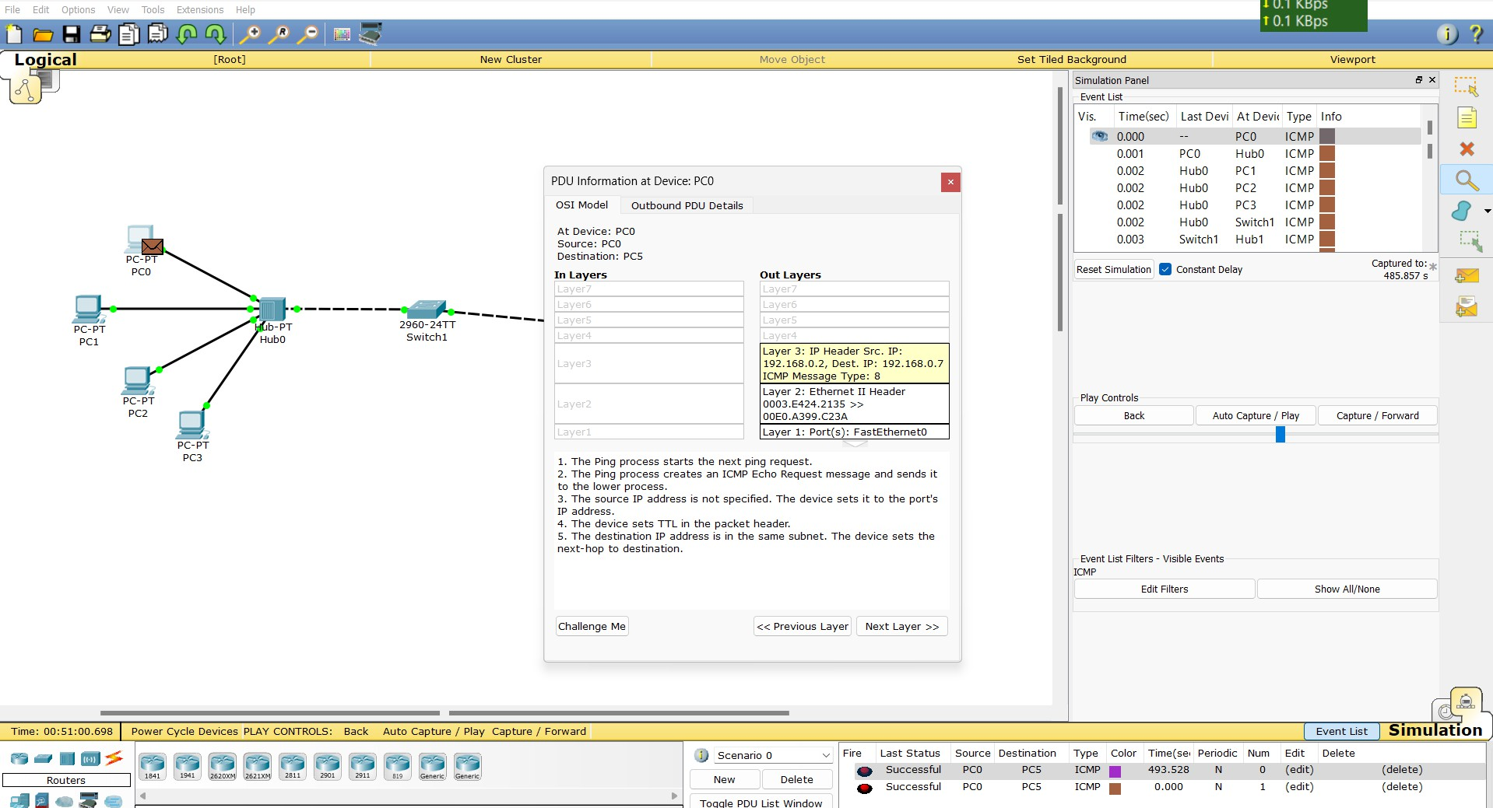( PDU of ICMP)

#### Computer Networks Lab - Assignment # 6

###### Capturing and analyzing Ethernet frames :

* 1. What is the 48-bit Ethernet address of your computer? Ans. Source: AmbitMicrosy_a9:3d:68 (00:d0:59:a9:3d:68)
  2. What is the 48-bit destination address in the Ethernet frame? Is this the Ethernet address of gaia.cs.umass.edu? (Hint: the answer is no). What device has this as its Ethernet address?

Ans. Address Destination: LinksysGroup_da:af:73 (00:06:25:da:af:73)

The destination MAC address in the Ethernet frame is "00:06:25:da:af:73." This MAC address does not correspond to the Ethernet address of "gaia.cs.umass.edu.

* 1. Give the hexadecimal value for the two-byte Frame type field. What upper layer protocol does this correspond to?

Ans. Type: IPv4 (0x0800)

The hexadecimal value for the two-byte Frame type field in the Ethernet II frame is "0800."

This corresponds to the IPv4 protocol at the upper layer. In Ethernet II frames, the Frame type field specifies the protocol of the payload encapsulated within the Ethernet frame. "0800" indicates that the payload is an IPv4

packet.

* 1. How many bytes from the very start of the Ethernet frame does the ASCII “G” in “GET” appear in the Ethernet frame? Next, answer the following questions, based on the contents of the Ethernet frame containing the first byte of the HTTP response message:

Ans. The ASCII "G" in "GET" appears 55th byte from the very start of the Ethernet frame.

* 1. What is the value of the Ethernet source address? Is this the address of your computer, or of gaia.cs.umass.edu (Hint: the answer is no). What device has this as its Ethernet address?

Ans. The value of the Ethernet source address is 00:06:25:da:af:73. This is not the address of my computer, nor is it the address of gaia.cs.umass.edu. This address belongs to the device with the manufacturer identified as LinksysGroup.

* 1. What is the destination address in the Ethernet frame? Is this the Ethernet address of your computer?

Ans. The destination address in the Ethernet frame is 00:d0:59:a9:3d:68. No, this is not the Ethernet address of my computer.

* 1. Give the hexadecimal value for the two-byte Frame type field. What upper layer protocol does this correspond to?

Ans. The hexadecimal value for the two-byte Frame type field is 0x0800. This corresponds to the upper layer protocol IPv4.

* 1. How many bytes from the very start of the Ethernet frame does the ASCII “O” in “OK” (i.e., the HTTP response code) appear in the Ethernet frame?

Ans. The ASCII "O" in "OK" (HTTP response code) appears in the Ethernet frame at byte offset 0x002E. This corresponds to byte 46 in decimal.

##### Computer Networks Lab - Assignment # 7

**Basic Subnetting and Routing Exercise**: Use Cisco Packet Tracer to perform subnetting of the given address space. Assign IP addresses to hosts in all the subnets and also to all the router interfaces. Also construct routing tables of each router and test for end-to-end connectivity.

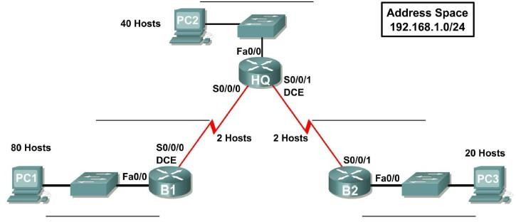

Objectives:

* + - Design and document an addressing scheme based on requirements.
    - Apply a basic configuration to the devices.
    - Select appropriate equipment and cable the devices.
    - Verify full connectivity between all devices in the topology.
    - Identify layer 2 and layer 3 addresses used to switch packets.
    - Test End to End Connectivity

Note:

1. Use Fixed Length Subnet Masking to perform IP subnetting
2. Repeat the exercise with Variable Length Subnet Masking to perform IP subnetting

### SOLUTION

Basic Subnetting and Routing Exercise Given Address Space: 192.168.1.0/24 **Fixed Length Subnet Masking (FLSM):**

#### Determine the number of subnets and hosts:

* + we need 4 subnets with equal number of hosts.
  + Subnet mask: /26 (255.255.255.192)
  + Each subnet can host up to 62 hosts.

#### Subnets:

* + **Subnet 1:** 192.168.1.0/26
    - Network Address: 192.168.1.0
    - Broadcast Address: 192.168.1.63
    - Host Range: 192.168.1.1 - 192.168.1.62
  + **Subnet 2:** 192.168.1.64/26
    - Network Address: 192.168.1.64
    - Broadcast Address: 192.168.1.127
    - Host Range: 192.168.1.65 - 192.168.1.126
  + **Subnet 3:** 192.168.1.128/26
    - Network Address: 192.168.1.128
    - Broadcast Address: 192.168.1.191
    - Host Range: 192.168.1.129 - 192.168.1.190
  + **Subnet 4:** 192.168.1.192/26
    - Network Address: 192.168.1.192
    - Broadcast Address: 192.168.1.255
    - Host Range: 192.168.1.193 - 192.168.1.254

#### Variable Length Subnet Masking (VLSM):

1. **Determine subnets based on host requirements:**
   * different subnets need different number of hosts.

#### Subnets:

* + **Subnet 1:** Requires 50 hosts
    - Subnet Address: 192.168.1.0/26
    - Network Address: 192.168.1.0
    - Broadcast Address: 192.168.1.63
    - Host Range: 192.168.1.1 - 192.168.1.62
  + **Subnet 2:** Requires 30 hosts
    - Subnet Address: 192.168.1.64/27
    - Network Address: 192.168.1.64
    - Broadcast Address: 192.168.1.95
    - Host Range: 192.168.1.65 - 192.168.1.94
  + **Subnet 3:** Requires 10 hosts
    - Subnet Address: 192.168.1.96/28
    - Network Address: 192.168.1.96
    - Broadcast Address: 192.168.1.111
    - Host Range: 192.168.1.97 - 192.168.1.110
  + **Subnet 4:** Requires 5 hosts
    - Subnet Address: 192.168.1.112/29
    - Network Address: 192.168.1.112
    - Broadcast Address: 192.168.1.119
    - Host Range: 192.168.1.113 - 192.168.1.118

#### Router Configuration:

* + we have routers connecting each subnet.

#### IP Addresses:

##### Router 1 Interfaces:

* + - G0/0: 192.168.1.1/26
    - G0/1: 192.168.1.65/26

##### Router 2 Interfaces:

* + - G0/0: 192.168.1.129/26
    - G0/1: 192.168.1.193/26

#### Host Configuration:

* + Assign IPs to hosts within each subnet range.

*Routing Tables*

#### Router 1:

o ip route 192.168.1.128 255.255.255.192 G0/1

o ip route 192.168.1.192 255.255.255.192 G0/1

#### Router 2:

o ip route 192.168.1.0 255.255.255.192 G0/0

o ip route 192.168.1.64 255.255.255.192 G0/0

